How to Set Multi Doorbell call Indoor simultaneously.

Indoor Station FW: V1.5.0_181031

Doorbell FW: V1.4.5_180917

1. Set all Doorbell to Doorbell Device Type in VMS. **Device will reboot.**

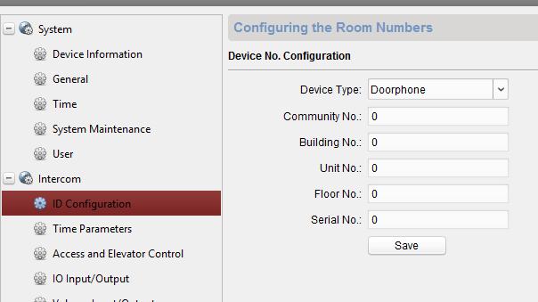

1. Set all Doorbell to Link Main Indoor Station (Select one indoor station to be “Main”)

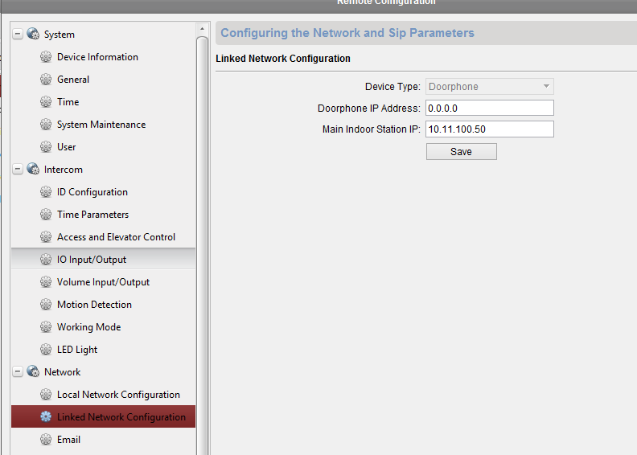

1. Set indoor station (Except one linked above) to Station Extension. (Might have to do on unit) **Device will reboot.**

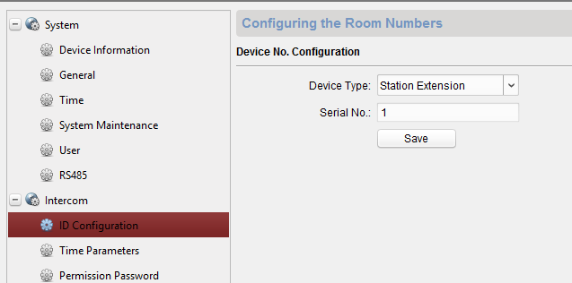

NOTE: For multiple indoor station, change Serial # (1, 2, 3, etc.)

1. Link indoor extensions to main indoor station (same IP step 2)

